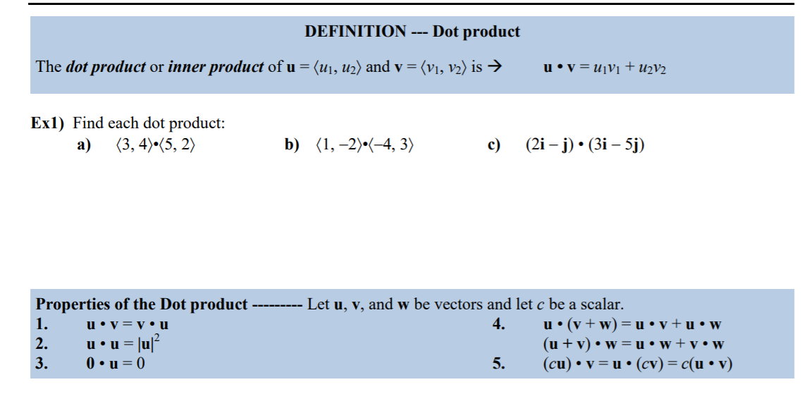Precalculus Notes: Dot Product and its Applications

***Ex 2) Operations with vectors (including dot product) can be combined***

Let  ; find the following:

1. 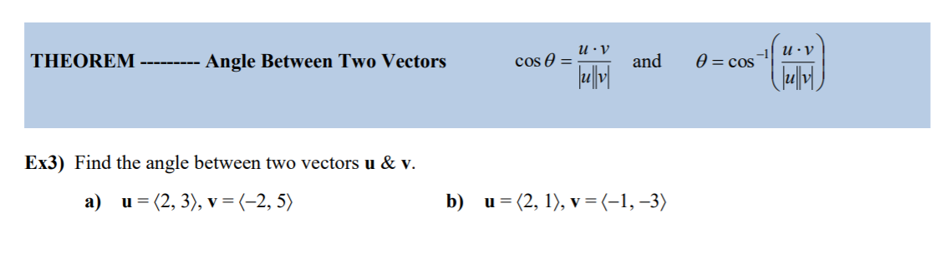  b)  c) 

