Law of Cosines Practice:
Solve each triangle. Round sides to nearest tenth and angles to nearest degree:
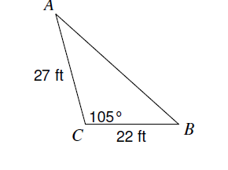  1. | 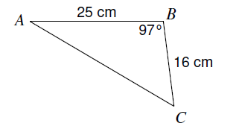  2.
3. 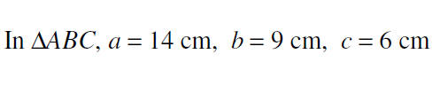 | 4. 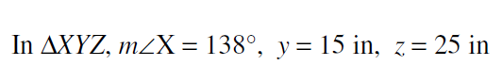
5. 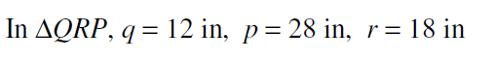

Find the area to the nearest tenth using Heron’s Formula:
6. 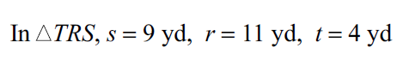

7. 