Law of Cosines

 As always, use an inverse function when solving for an angle measure.

Example 1 Solve given the diagram.

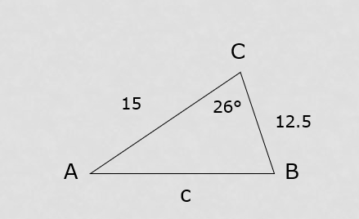

__________________________________________________________________________________________________

Example 2 (SSS): Solve  given a = 9.47 ft., b = 15.9 ft. and c = 21.1 ft.

__________________________________________________________________________________________________

Use Heron’s Formula to find the area of an oblique triangle given SSS

Step 1: Find the semi – perimeter of the triangle: 

Step 2: Apply *Heron’s formula*: 