Recall from geometry:

* The *Triangle Sum Conjecture*: The sum of the angles in any triangle is equal to ________.
* The *Triangle Inequality Theorem:* The longest side is opposite the ___________ angle, the medium side is

opposite the ____________ angle, and the shortest side is opposite the _____________angle.

* When solving for an angle measure, use an __________________.

__________________________________________________________________________________________

We begin our study of *oblique* triangles. An oblique triangle is a ______________________ triangle. We use an uppercase

letter to denote an _______________ and a lower case letter to denote a ______________.

There are 5 cases that we will be studying: AAS, ASA, SSA, SAS, and SSS.

We begin today with AAS (______________________________) and ASA (_____________________________________).

Both of these cases can be solved using the Law of Sines.

____________________________________________________________________________________________________

# Law of Sines:

If ΔABC is any ***oblique*** (non-right triangle), where a, b, and c are lengths of the sides opposite the angles

with measures A, B, and C respectively, then

c

a

B



C

A

b

** Use the Law of Sines when you know the measures of two angles and any side of a triangle, or 2 sides

and an angle across from one of the sides.

**Solve the following triangles.**

|  |  |
| --- | --- |
|  |  |
|  |  |
|  |  |

Example 1: *m*∠ C = 102, *m*∠A = 28, a = 27

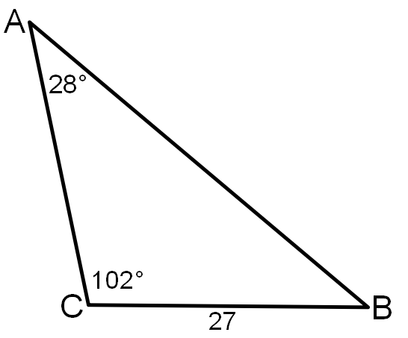

Example 2: *m*∠A = 66°, *m*∠B = 34°, *c* = 12

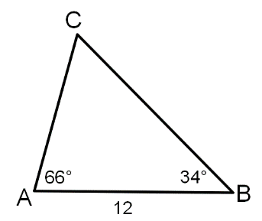

|  |  |
| --- | --- |
|  |  |
|  |  |
|  |  |

Example 3: Solve triangle  given

|  |  |
| --- | --- |
|  |  |
|  |  |
|  |  |



Example 4: In , solve for side *a* given the measures

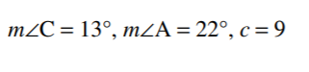

___________________________________________________________________________________________________________

Finding the area of an oblique triangle.

Given two sides and the included angle of an oblique triangle, the 

Example 5: Example 6:



    
    
    
    
    

    
    
    
    
    