Precalculus

Final Review – Fall 2018

Use the fundamental identities to simplify.

1. Which of the following expressions is **not equal** to 1?
2.  C. 
3.  D. none of these
4. What is the simplest form of  ?
5.  C. 
6.  D. 
7. Which of the following is equivalent to  ?
8.  B.  C.  D. 
9. Simplify 
10.  B.  C.  D. 
11. Which expression is equivalent to  ?
12.  B.  C.  D. 
13. Simplify 
14.  B.  C.  D. 
15. Find the exact value of 
16.  B.  C.  D. undefined
17. Evaluate 
18.  B.  C.  D. 
19. Write an equation of the parabola with a focus at (3, -1) and directrix equation y = 5.
20.  C. 
21.  D. 
22. Write an equation of the parabola with a vertex at the origin and focus at (0, 3).
23.  C. 
24.  D. 
25. Identify the vertex, focus, and directrix of the graph of 
26. Vertex (5, -1), focus (5, 5), directrix x = -1
27. Vertex (1, -5), focus (7, -5), directrix y = -5
28. Vertex (-1, 5), focus (-7, 5), directrix x = 6
29. Vertex (-1, 5), focus (5, 5), directrix x = -7
30. Which of these graphs is  ?
31. 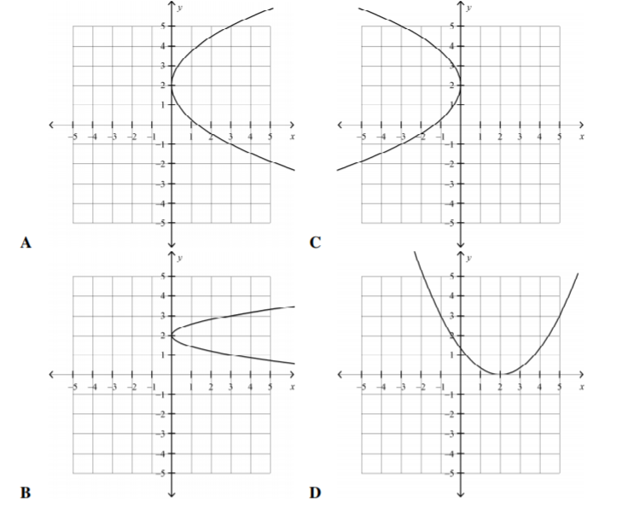
32. Write an equation of a circle with a center at (-1, 4) and a radius of 5.
33.  C. 
34.  D. 
35. Identify the conic section  4x2 + 16x – 9y = 17 – y2
36. Circle B. ellipse C. hyperbola D. parabola
37. Write an equation of an ellipse with a center (-2, 4), a major axis 10 units long, and a minor axis 8 units long. Graph the ellipse.

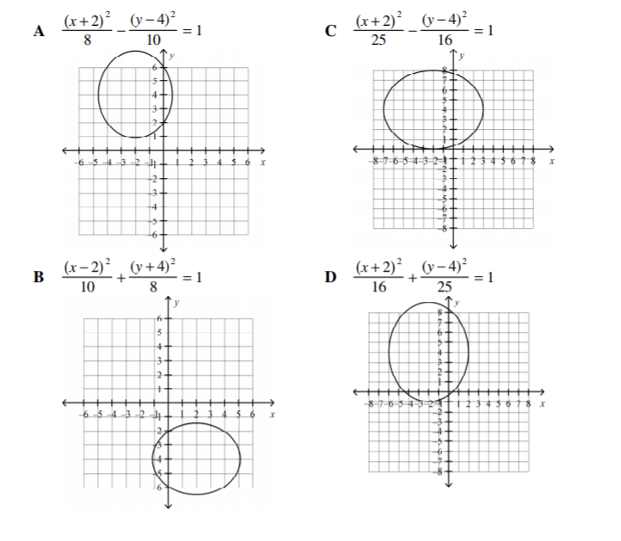

1. Identify the center and graph the hyperbola with equation 

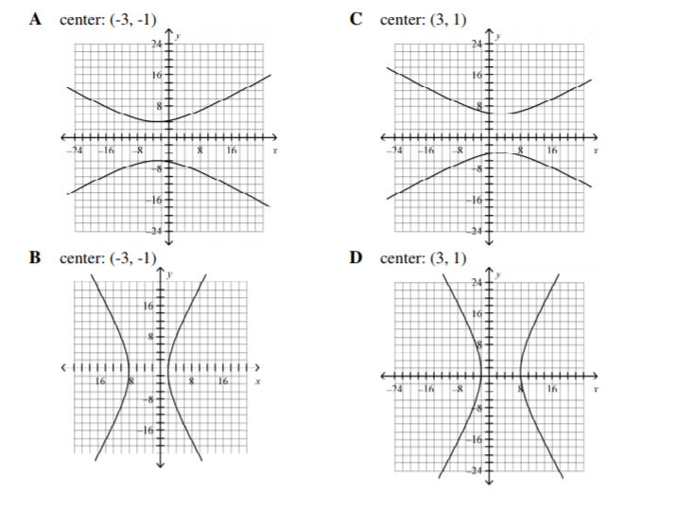

1. Find the center of the ellipse: 3x2 + 4y2 +18x – 32y – 5 = 0
2. (3, -4) B. (-3, 4) C. (4, -3) D. (-4, 3)
3. Find the center and radius of the circle: x2 + y2 – 8x + 10y – 6 = 0
4. Center (4, -5), radius =  C. center (4, -5), radius = 
5. Center (-4, 5), radius = 47 D. center (-4, 5), radius = 
6. Graph 5x2 + 10y2 = 50

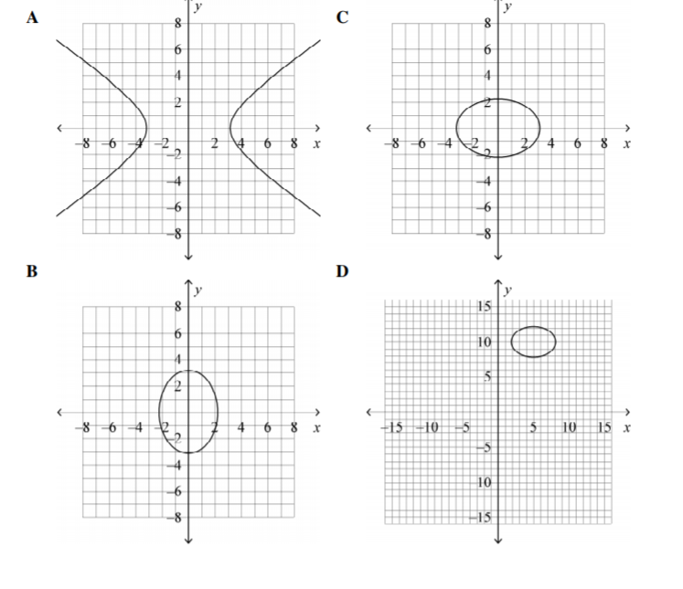

1. Find the vertex and tell the direction of opening for the parabola x2 – 8x – y + 19 = 0
2. (4, 3); down C. (4, 3); up
3. (-4, 3) up D. (4, -3); right

For the next two problems, identify the conic type, the center and the foci.

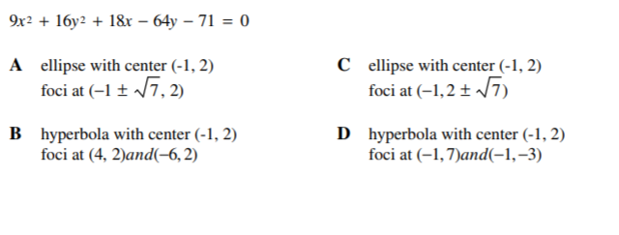



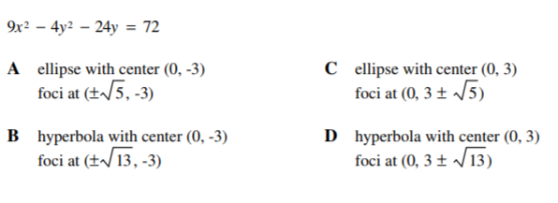



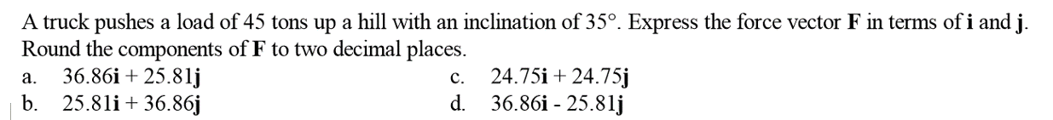

2. Find the dot product of 

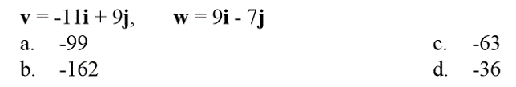

1. 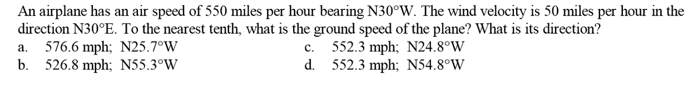

1. 